Year 4 Autumn 1 KIRF Multiples of 1000 and 25
Children need to be able to know the multiples for 1000 and 25 and count in sequences involving these. e.g
1x1000= 1000
- x1000 = 2000
- x 1000= 3000
- x 1000= 4000
- x 1000= 5000
- x 1000= 6000
- x 1000=7000
- x 1000= 8000
- x 1000= 9000
- x 1000= 10,000
They should be able to count in 1000s in sequences e.g
1000, , 3000, , 5000, , 7000
1x25= 25
- x25 =50
- x 25= 75
- x 25= 100
- x 25= 125
- x 25= 150 7 x 25=175
- x 25= 200
- x 25= 225
- x 25= 250
They should be able to count in 1000s in sequences e.g
1000, , 3000, , 5000, , 7000

Top Tips
The secret to success is practising little and often. Use time wisely. Can you practise these KIRFs while walking to school or during a car journey? You don’t need to practise them all at once: perhaps you could have a fact family of the day. If you would like more ideas, please speak to your child’s teacher.

Year 4 Autumn 2 KIRF
Multiplication and division facts for the 6 times table
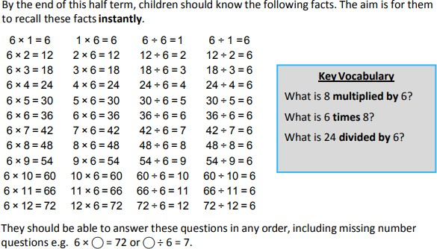
Top Tips
The secret to success is practising little and often. Use time wisely. Can you practise these KIRFs while walking to school or during a car journey? You don’t need to practise them all at once: perhaps you could have a fact family of the day. If you would like more ideas, please speak to your child’s teacher.

Songs and Chants – You can buy Times Tables CDs or find multiplication songs and chants online. If your child creates their own song, this can make the times tables even more memorable.

Double your threes – Multiplying a number by 6 is the same as multiplying by 3 and then doubling the answer. 7 × 3 = 21 and double 21 is 42, so 7 × 6 = 42.
Buy one get three free – If your child knows one fact (e.g. 3 × 6 = 18), can they tell you the other three facts in the same factfamily? Warning! – When creating fact families, children sometimes get confused by the order of the numbers in the division number sentence. It is tempting to say that the biggest number goes first, but it is more helpful to say that the answer to the multiplication goes first, as this will help your child more in later years when they study fractions, decimals and algebra. E.g. 6 × 12 = 72. The answer to the multiplication is 72, so 72 ÷ 6 = 12 and 72 ÷ 12 = 6

Year 4 Spring 1 KIRF
Multiplication and division facts for the 9 and 11 times table
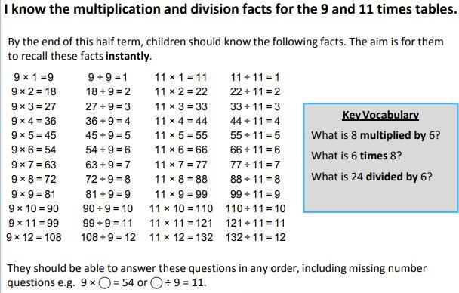

Top Tips
The secret to success is practising little and often. Use time wisely. Can you practise these KIRFs while walking to school or during a car journey? You don’t need to practise them all at once: perhaps you could have a fact family of the day. If you would like more ideas, please speak to your child’s teacher.

Look for patterns – These times tables are full of patterns for your child to find. How many can they spot? Use your ten times table – Multiply a number by 10 and subtract the original number (e.g. 7 × 10 – 7 = 70 – 7 = 63). What do you notice? What happens if you add your original number instead? (e.g. 7 × 10 + 7 = 70 + 7 = 77)
What do you already know? – Your child will already know many of these facts from the 2, 3, 4, 5, 6, 8 and 10 times tables. It might be worth practising these again!

Year 4 Spring 2 KIRF Decimal equivalents to fractions
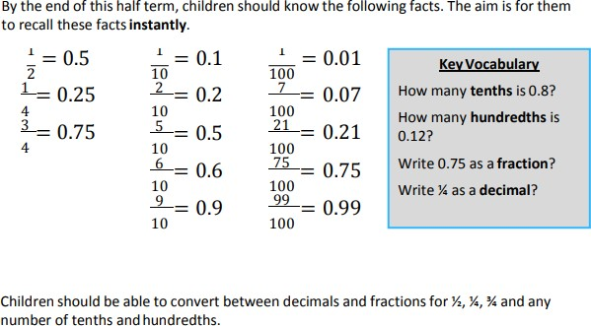

Top Tips
The secret to success is practising little and often. Use time wisely. Can you practise these KIRFs while walking to school or during a car journey? You don’t need to practise them all at once: start with tenths before moving on to hundredths. If you would like more ideas, please speak to your child’s teacher.

Play games - Make some cards with pairs of equivalent fractions and decimals. Use these to play the memory game or snap. Or make your own dominoes with fractions on one side and decimals on the other.

Year 4 Summer 1 KIRF
Multiplication and division facts for the 7 and 12 times table
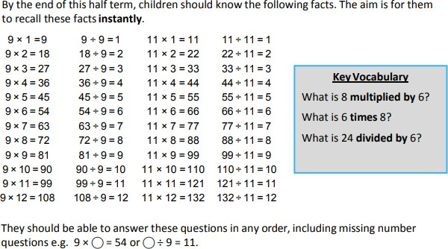

Top Tips
The secret to success is practising little and often. Use time wisely. Can you practise these KIRFs while walking to school or during a car journey? You don’t need to practise them all at once: perhaps you could have a fact family of the day. If you would like more ideas, please speak to your child’s teacher.

Look for patterns – These times tables are full of patterns for your child to find. How many can they spot?
Use your ten times table – Multiply a number by 10 and subtract the original number (e.g. 7 × 10 – 7 = 70 – 7 = 63). What do you notice? What happens if you add your original number instead? (e.g. 7 × 10 + 7 = 70 + 7 = 77)
What do you already know? – Your child will already know many of these facts from the 2, 3, 4, 5, 6, 8 and 10 times tables. It might be worth practising these again!

Year 4 Summer 2 KIRF I can Scale number facts by 10
Apply place-value knowledge to known additive and multiplicative number facts (scaling facts by 10), for example:
8 + 6 = 14 and 14- 6= 8 so 80 + 60 = 140 and 140- 60=80
3 x 4 =12 and 12÷ 4 = 3 so 30 x 4 =120 and 120÷ 40 = 3
Children need to apply this knowledge to number facts within 20 and multiplication facts up to 12 x 12. Look at previous fact sheets for facts within 20 and multiplication facts for 12 x 12.
Top Tips
The secret to success is practising little and often. Use time wisely. Can you practise these KIRFs while walking to school or during a car journey? You don’t need to practise them all at once: perhaps you could have a fact family of the day. If you would like more ideas, please speak to your child’s teacher.
Games: Play fact tennis. For example, I say 7 + 5 = 12 and the partner then says the fact scaled by 10 so 70 + 50 = 120 and repeat with different facts.

