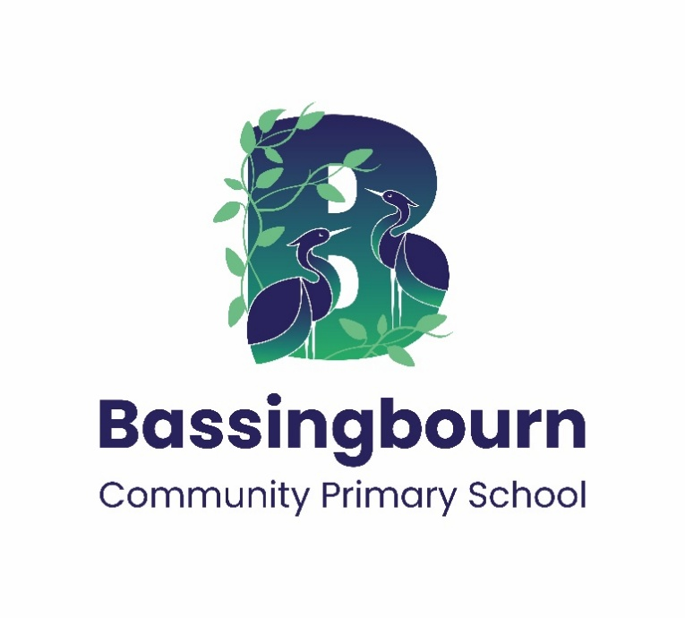

Bassingbourn Community Primary School

Behaviour Policy

This policy was ratified on: 24th September 2026

Implemented on: 24th September 2026

Review date: September 2027

Content
- Statement of Intent
- Policy overview
- Definitions linked with behaviour
- Aims of our policy
- Roles and responsibilities
- The graduated approach to behaviour at Bassingbourn Community Primary School
- Child on child abuse
- Suspension and permanent exclusion
- Readmission meetings following a suspension (fixed-term or internal)
- Physical intervention and restraint
- Checking Pupils’ Belongings Safely
- How we aim to respond to behaviour
- Logging and monitoring behaviour
- Behaviour in the Early Years Foundation Stage (EYFS)
- Pupils with Special Educational Needs and/or Disabilities (SEND)
- The Hub and Behaviour Expectations
- Damage to Pupils' Personal Belongings and School Property
- Complaints and Appeals
- Appendix list

- Statement of Intent

This policy sets out the framework for promoting valued behaviour, preventing and addressing detrimental behaviour, and responding to challenging circumstances.
The Governing Body, Headteacher and staff of Bassingbourn Community Primary School are committed to:
- Providing a safe, nurturing learning environment
- Teaching and modelling valued behaviours
- Using a consistent and therapeutic approach to behaviour
- Implementing a graduated response to meet pupils’ individual needs
- Maintaining high standards of conduct for all pupils and staff
- Ensuring behaviour policies are applied fairly, equitably and in line with legal duties (Equality Act 2010, SEND Code of Practice, DfE guidance on exclusions, use of force and behaviour in schools).
The Governing Body will monitor the impact of this policy and will support staff to implement it with fidelity across the school.

- Policy Overview

At Bassingbourn Community Primary School, we believe that valued behaviour is inseparable from effective teaching and learning. Our behaviour policy is built on two simple expectations that underpin all relationships and interactions in our school:
- Be Safe
- Be Respectful
By consistently modelling and supporting these expectations, we aim to create a calm, safe and inclusive school where all children can thrive.
Our approach is based on the Cambridgeshire Therapeutic Thinking (CTT) Strategy — a framework that helps us understand the causes of behaviour and respond to it with empathy and structure. All staff are trained in this approach to ensure consistency and shared understanding.
Our policy also promotes:
- Positive relationships and emotional wellbeing
- Equality, diversity and inclusion, in line with the Equality Act 2010
- A graduated approach that recognises and responds to individual needs
- Equipping children with skills to self-regulate, build resilience, and develop positive relationships.

- Definitions linked with behaviour

- Therapeutic thinking - An approach to behaviour that prioritizes the helpful feelings of everyone within the dynamic
- Challenging behaviour - Challenging Behaviour is how we talk about a range of behaviour which some people with severe learning disabilities may display when their needs are not being met.
- Valued behaviour - Behaviour held in high regard by an individual, the community or the environment.
- Difficult detrimental behaviour - Behaviour that hurts or hinders an individual, the community or the environment.
- Dangerous detrimental behaviour - Behaviour which will imminently result in injury to self or others, damage to property or behaviour that would be considered criminal if the person was the age of criminal responsibility, such as racist abuse.
- Reward - A planned logical response to a behaviour designed to help children learn and develop transferable behaviour, leading to the likelihood of this being repeated in all contexts.
- Consequence - A planned logical response to a behaviour. Logical responses to detrimental behaviour help children learn and develop valued behaviour, enabling behaviour change.
- Protective consequences - are necessary measures to manage the risk of harm. Protective consequences may limit freedoms.​
- Educational consequences - progress in the child’s understanding and engagement. Where protective consequences are necessary, educational consequences should allow the gradual removal of adaptations. Educational consequences return freedoms.​
- Internal seclusion – A protective consequence that involves a pupil spending a period out of their classroom, to allow the team around the pupil to formulate a plan to further support them. The seclusion length and location with depend on the context of the dangerous detrimental behaviour
- Fixed term suspension - when a child is removed from school and the education provided is in a different setting e.g., work from home.
- Behaviour at Bassingbourn Community Primary School is either valued or detrimental
- Feelings at Bassingbourn Community Primary School are either helpful or unhelpful
- Experiences at Bassingbourn Community Primary School are either positive or negative

- Aims of our policy

The behaviour policy at Bassingbourn Community Primary School, aims to do the following:
- To promote the inseparable link between teaching, learning and valued pupil behaviour.​
- To improve staff confidence and safety​ when responding to different types of pupil’s behaviour
- To support the inclusion of all pupils who attend Bassingbourn Community Primary school, to ensure their safety and wellbeing
- To continue to understand the different reasons for detrimental behaviour, with a view of educating and developing pupils
- To establish a consistent system of logging and monitoring behaviour

- Roles and Responsibilities

Governors are responsible for:
- Ensuring the school adheres to the governing body’s principles of behaviour management through its policies and practices
- Ensuring the school complies with equality legislation
- Monitoring the frequency and patterns of behaviour incidents and the actions taken by the school to address these
- Monitoring the rates of suspensions and exclusions to ensure the policy is applied fairly and consistently

The Headteacher, with support from the Leadership Team (LT), is responsible for:
- Ensuring that all staff are aware of their responsibilities in relation to behaviour management
- Providing training for staff in the Cambridgeshire Therapeutic Thinking (CTT) approach to ensure policies and procedures are followed consistently
- Overseeing the implementation of Therapeutic Plans and other support plans for pupils who need additional support, including pupils with SEND and vulnerable pupils
- Ensuring effective systems are in place for recording and reporting behaviour incidents (e.g. BromCom)
- Ensuring that all behaviour incidents are dealt with effectively and that staff and pupils receive appropriate support
- Reporting prejudice-related incidents, suspensions and exclusions to the Governing Body and Local Authority
- Setting and monitoring equality objectives, in partnership with the Governing Body and other school leaders
Staff members are responsible for:
- Complying with school policies and procedures
- Attending and implementing behaviour-related training, including CTT
- Seeking to understand the root cause of behaviour and referring to pastoral or safeguarding staff where appropriate
- Modelling respectful behaviour, with unconditional positive regard for all pupils
- Working collaboratively with other staff and parents/carers to support pupils’ behaviour
- Reporting incidents promptly and accurately

Parents and carers are expected to:
- Support the school by modelling and encouraging our values: Be Caring, Be Resilient, Be Excellent — and our behaviour expectations: Be Respectful, Be Safe
- Encourage independence and self-discipline, and take an interest in all aspects of their child’s school life
- Foster positive relationships with the school and support the implementation of this behaviour policy
- Help their child understand appropriate behaviour in different situations and reinforce awareness of school rules and expectations
- Sign the Home-School Agreement, ensuring that both children and parents understand their rights and responsibilities

Pupils are expected to:
- Follow the school’s two core behaviour expectations: Be Safe and Be Respectful
- Demonstrate valued behaviour towards other pupils and all adults
- Take responsibility for their actions and reflect on how their behaviour affects others
- Engage positively with learning and make the most of every opportunity to develop their skills
- Follow instructions given by adults and adhere to school routines
- Show kindness, consideration and respect for difference and diversity
- Contribute to creating a positive and safe learning environment
- Take part in restorative conversations when needed and work towards repairing relationships
- Help look after school property, shared spaces and their own belongings

- The Graduated approach to behaviour at Bassingbourn Community Primary School

As part of the Bassingbourn Community Primary School’s graduated approach and in line with aspects of the CTT strategy, we follow 5 stages in dealing and responding to behaviour within our school setting. Whilst we recognise the importance of following the stages in a linear motion, we also understand that if in the best interest of the pupil, certain circumstances may result in stages being skipped to provide adequate support for the pupil.
Stage | Actions that may be taken
Stage 1 – Universal (Behaviour Curriculum) | - Check existing knowledge, skills and understanding  - Complete a pupil induction  - Establish a realistic starting point  - Establish realistic next steps  - Identify opportunities for teaching and learning linked to real-world events/experiences  - Provide guided and supported practice of skills  - Refer to school behaviour policy  - Review progress
Stage 2 – Universal plus (Behaviour Policy) | - Check the identified behaviour is covered in the policy  - Support the pupil in line with policy  - Monitor and record the behaviour and the impact the policy is having  - Implement further analysis and planning  - Review progress
Stage 3 – Targeted (Early Prognosis) | - Create an Early Prognosis document for the pupil  - Create and follow an Early prognosis Assess Plan Do Review  - Set a review date  - Review progress
Stage 4 – Targeted Plus (Predict, Prevent and Progress) | - Complete a risk calculator  - Updated and review all information within targeted  - Identify protective and educational consequences  - Complete Anxiety Analysis for relevant variables  - Create a predict, prevent & progress plan  - Analyse dysregulation and values and beliefs  - Set a review date  - Review progress  - Implement further analysis and planning
Stage 5 – Specialist (Therapeutic Plan) | - Update all information in Targeted and Targeted plus  - Complete the Therapeutic Tree for the individual pupil  - Complete a detailed Therapeutic risk management plan  - Set review date  - Consider groups dynamic options  - Review progress  - Involve muilti-agency colleagues in review and identifying next steps

- Child on Child Abuse

At Bassingbourn Primary, we recognise that some pupils may display abusive behaviours towards one another, including sexual harassment and/or violence. Where this happens, incidents or allegations must be referred to a member of the school's leadership team immediately to ensure appropriate support and intervention is put in place for both parties.
- Suspension and Permanent Exclusion

Only the headteacher has the authority to issue a fixed-term suspension or permanent exclusion. Suspension and exclusion will only be used as a last resort and the headteacher will be guided by Department for Education (DfE) and Cambridgeshire County Council advice on all suspensions and permanent exclusions. The Chair of Governors will be informed if either of these sanctions are used. Please refer Bassingbourn Community Primary School’s Suspensions and Exclusions Policy for more information
- Re-admission meetings following a suspension (fixed-term or internal)

At Bassingbourn Community Primary School, we believe that a carefully planned and supportive re-admission meeting is an important part of helping pupils successfully reintegrate after a suspension.
The purpose of the re-admission meeting is to:
- Welcome the pupil back into the school community in a positive and supportive manner
- Ensure the pupil understands the reasons for the suspension and has an opportunity to reflect on the behaviour
- Involve parents/carers in supporting their child’s next steps
- Agree any protective measures that will support behaviour change
- Review or update any existing support plans e.g., Therapeutic Plans
- Identify any additional support needed for the pupil’s wellbeing and learning
- Re-establish clear expectations, including the values of Be Safe and Be Respectful
The meeting will be attended by the pupil, parents/carers, the Headteacher (or delegated leader), and other relevant staff where appropriate (such as SENDCo).
We aim to use the re-admission process to strengthen the partnership between school, pupil and family — promoting a therapeutic, inclusive and forward-looking approach that reduces the likelihood of future suspensions or permanent exclusion
- Physical Intervention and Restraint

All members of staff are aware of the regulations regarding the use of reasonable force by school staff, as set out in Use of Reasonable Force in Schools: Advice for Headteachers, Staff and Governing Bodies (DfE, 2013).
In line with the school’s Code of Conduct Policy and Safeguarding and Child Protection Policy, staff must never use force as a punishment for behaviour. They may, however, need to intervene physically to restrain a child if they are in danger of hurting themselves or to prevent injury to another child. Use of reasonable force will only ever be used as a last resort, and this will always be reported to parents/carers and recorded on the school’s safeguarding system (My Concern). The actions that staff will take in these circumstances are in line with government guidelines on the restraint of children (DfE, 2013).
Bassingbourn Community Primary School is a no touch/contact school, and physical intervention will always be a last resort following the exhaustion of all appropriate non-contact regulation strategies suitable for each pupil. All staff members are trained in Cambridge Therapeutic Thinking approaches, which focus on de-escalation strategies and restoration.

- Checking Pupils’ Belongings Safely

If a member of staff has reasonable grounds to suspect that a pupil is in possession of a banned item, a pupil can be instructed to undergo a search without consent: parental permission or pre-notification is not required. However, only the headteacher, or a member of staff authorised by the headteacher, can carry out a search. Staff are also permitted to examine data files held on personal devices during a search, with the authorisation of the headteacher.
Prohibited items include:
- Knives and weapons
- Alcohol
- Illegal drugs
- Stolen items
- Tobacco and other related smoking items (e.g. vapes, lighters, etc.)
- Fireworks
- Pornographic images
- Any item that has been or is likely to be used to commit an offence, cause personal injury or damage to school property.
Searching and screening of pupils is conducted in line with the guidance Searching, Screening and Confiscation: Advice for Schools (DfE, 2022).

- How we aim to respond to behaviour

In line with the CTT strategy Bassingbourn Community Primary school, separate behaviour into three different categories (as listed below). The response to each behaviour is dependent on the type of behaviour displayed by the pupil and the context of the behaviour. It is important for all staff to treat each behaviour event on a case-by-case basis, to ensure that priority of responding to the behaviour remains unpicking the route cause.

Type of Behaviour | Examples of Behaviour (But not limited to): | How we respond to the Behaviour (But not limited to):
Valued Behaviour | As demonstrated in our ‘Whole School Behaviour & Safeguarding Curriculum’, we expect pupils to demonstrate the following valued behaviours in line with their key stage:  EYFS (Reception)  Being Safe  - Follows classroom routines and safety rules (e.g. lining up, walking indoors)  - Keeps hands and feet to self  - Tells an adult if something feels wrong or someone is hurt  - Uses classroom equipment safely  - Gives others space when playing and learning  - Screens are for learning and fun, but we use them with an adult  - We tell a grown-up if something on a screen makes us feel funny or scared  - We always ask permission before using a device or watching something  Being Respectful  - Greets adults and friends with a smile or hello  - Listens with eyes and ears during carpet time and class discussions  - Takes turns when talking or playing  - Uses kind words and gentle hands  - Looks after toys and books  - Tries new things and asks for help when needed  Key Stage 1 (Years 1–2)  Being Safe  - Follows instructions the first time and knows why rules keep us safe  - Walks safely in school and uses tools properly  - Gives personal space and keeps hands/feet to self  - Recognises when to ask for adult help  - Moves around school sensibly and safely  - Keeps personal information private (e.g. name, school, birthday)  - Knows not everything online is true or safe — asks an adult if unsure  - Uses polite and friendly language online  Being Respectful  - Greets adults and peers politely  - Listens without interrupting  - Shares, takes turns, and helps others  - Uses calm, kind language in class  - Looks after classroom resources  - Tells the truth and explains when something goes wrong  Lower Key Stage 2 (Years 3–4)  Being Safe  - Responds promptly to adult directions  - Uses resources and furniture responsibly  - Keeps shared spaces clean and organised  - Understands and respects physical boundaries  - Seeks help respectfully when needed  - Follows routines (e.g. lining up, fire drills)  - Understands digital footprint and online privacy  - Uses strong passwords and never shares them  - Knows what cyberbullying is and how to report it  - Begins questioning online content reliability  Being Respectful  - Uses polite greetings  - Listens actively and respectfully  - Collaborates, shares ideas, and takes turns  - Speaks kindly, even in disagreement  - Accepts responsibility and owns up to mistakes  - Begins tasks without fuss and contributes in discussions  Upper Key Stage 2 (Years 5–6)  Being Safe  - Makes safe choices independently  - Keeps learning areas organised and uses equipment safely  - Asks for help respectfully  - Uses appropriate voice levels in class  - Follows routines without reminders  - Respects others’ boundaries and sets a good example  - Manages online relationships respectfully  - Protects digital identity and data  - Understands consequences of sharing content online  - Knows how to block/report online issues  - report concerns persistently until heard  Being Respectful  - Greets others with maturity  - Listens actively and shows engagement  - Shares, leads, and collaborates in group tasks  - Demonstrates honesty and accountability  - Participates fully and stays on task  - Supports others with empathy and respect | - Use gestures like thumbs up, a smile, or a nod to acknowledge valued behaviours without interrupting the flow of the lesson.  - Give immediate specific, positive feedback that highlights pupils’ valued behaviour.  - Use systems like stickers and positive phone calls to parents to acknowledge valued behaviour.  - Recognise pupils for their positive behaviour in front of his/her peers.  - Offer special privileges (e.g., leading a line, choosing a classroom job) as rewards for consistent valued behaviour.  - Provide pupil with the Celebration Award certificate recognising his/her specific achievements, such as kindness, responsibility, or improvement in focus.  - Ask pupil to use their 5-point scale to reflect on how his/her valued behaviours and achievements are making him/her feel.  - Award house points to equivalated to pupil receiving a Bronze, Silva or Gold house point certificate at the end of each term
Difficult detrimental behaviour | - Continues to repeatedly shout out and/or make noises, despite reminders.  - Uses swear words or targeted language towards peers/adults (e.g. derogatory, racist, homophobic or misogynistic terms).  - Purposely tries to upset a peer or adult e.g. saying, ‘no’, ‘shut up’, ‘go away’, ‘why should I?’.  - Purposely ignores instructions from an adult.  - Refuses to take part in learning tasks e.g. not sitting in his/her chair or completing set independent learning.  - Refuses to move for his/her learning e.g. refusing to attend assembly or go to the library.  - Interrupts learning for another class e.g. entering a class other than his/her own, banging on classroom doors and/or windows.  - Purposely snatches equipment from peers.  - Breaks school equipment such as pencils and rulers, both accidentally and purposely.  - Refuses to come into the classroom/school building following break/lunch.  - Wanders from lessons.  - Hides e.g. under tables/chairs.  - Runs up and down the school corridors.  - Severely misuses technology, such as searching and sharing harmful content, cyberbullying, or using school devices for inappropriate purposes. | - Use of school scripts throughout the pupil’s behaviour escalating  - Encourage the pupil to use the Zones of Regulation to indicate his/her emotions and discuss why he/she is feeling that way. Try to identify the root cause for the behaviour e.g. is the pupil hungry? Did anything happen before school/at play/at lunch?  - Encourage pupils to use a 5-point scale and discuss why he/she is feeling a certain way.  - Provide pupils with an educational consequence to progress the child’s understanding and engagement.  - Restorative conversation  - Contact parents to discuss the behaviour  - Behaviour recorded on BromCom in line with the school’s behaviour policy.  - If a pupil continues to regularly display Difficult detrimental behaviour, then the class teacher will discuss with the school’s behaviour lead about implementing Bassingbourn Community Primary schools graduated approach to behaviour  - If the pupils display difficult detrimental behaviour on multiple occasions throughout a school half term, the pupil will be placed on a behaviour report. The behaviour report is used to allow the pupil to take accountability for their actions/success, whilst also providing a consistent method of communication between school and home
Dangerous detrimental behaviour | - Makes threats to peers/adults with intent to harm.  - Hits peers/adults with and without intent to harm.  - Purposely ignores instructions that will impact their safety.  - Purposely throws school furniture.  - Purposely kicks/slams school furniture including doors in communal spaces.  - Climbs on school furniture with little regard for their own safety.  - Climbs trees and gates and refusing to come down with little regard for their own safety.  - Purposely damages school equipment/environment including ripping displays.  - Inappropriately touches a peer or member of staff which is deemed unsafe and/or overly sexualised.  - Wanders from the building.  - Absconds from the school premises. | - Encourage the pupil to use the Zones of Regulation to indicate his/her emotions and discuss why he/she is feeling that way. Try to identify the root cause for the behaviour e.g. is the pupil hungry? Did anything happen before school/at play/at lunch?  - Encourage pupil to use a 5-point scale and discuss why he/she is feeling a certain way.  - Provide pupils with an educational consequence to progress the child’s understanding and engagement.  - Contact parents to discuss the behaviour  - Behaviour recorded on BromCom in line with the school’s behaviour policy  - If a pupil continues to regularly display Difficult detrimental behaviour, then the class teacher will discuss with the school’s behaviour lead about implementing Bassingbourn Community Primary schools graduated approach to behaviour  - The pupil maybe be internally secluded (time length and location to depend on circumstance) to provide the child with time to reset and allow the school to put an effective plan in place which is in the interest of the pupil safety, education and wellbeing  - Where a serious or repeated dangerous detrimental behaviour event has occurred, the Headteacher has the authority to use a fixed-term suspension, internal suspension, or permanent exclusion in line with statutory guidance and the school’s Behaviour Policy. Suspension is always used as a last resort. It is not a punishment in isolation but is used as a circuit breaker to allow the school, relevant staff, parents/carers, and external agencies to come together to formulate an appropriate plan that will support the pupil positively going forward. This process ensures that time is taken to understand the underlying causes of the behaviour, review current provision, and implement targeted strategies and adjustments to reduce the risk of future incidents. The decision to suspend will always be proportionate, fair, and made in the best interests of the pupil, their peers, and the wider school community to maintain safety, dignity, and a calm learning environment. Permanent exclusion will only be considered in the most extreme circumstances, where all other supportive and reasonable options have been exhausted, and where allowing the pupil to remain in school would seriously harm the education or welfare of others or themselves.  - Restorative conversation

- Logging and Monitoring Behaviour
At Bassingbourn Community Primary School, we are committed to using a clear and consistent system for recording all behaviour events. This helps us to:
- Track individual pupils' progress and patterns of behaviour over time
- Provide accurate data to inform our graduated response
- Monitor the effectiveness of interventions and therapeutic approaches
- Identify pupils who may require additional support
- Ensure leadership decisions are based on reliable evidence
- Report accurately to governors and external agencies
- Celebrate positive behaviour across the school
We use BromCom to record all behaviour events — both valued behaviours and detrimental behaviours. This allows us to develop a balanced and nuanced picture of each pupil’s behaviour journey.
Each behaviour event is assigned a numerical value (e.g. +1 for a House Point, -2 for Child-on-Child Abuse). This system enables:
- Early identification of trends or concerns
- Consistent thresholds for support plans (e.g. Behaviour Reports)
- Recognition of positive contributions to school life
- Data-led reflection at individual, class and whole-school level
Pupils’ behaviour points are reset at the start of each half term, and these scores are not shared with pupils or parents/carers — the purpose of this system is for internal analysis and improvement, not for ranking or comparison. The Headteacher regularly monitors behaviour data, reporting to the Governing Body and identifying areas for further development. The Governing Body also monitors exclusion rates and ensures the policy is applied fairly and consistently across the school.
In line with statutory duties, any suspensions (fixed term) or permanent exclusions are reported to the Local Authority.

- Behaviour in the Early Years Foundation Stage (EYFS)

At Bassingbourn Community Primary School, we recognise that children in the Early Years Foundation Stage (EYFS) are at an early stage in developing their understanding of behaviour expectations and self-regulation.
Our behaviour approach in EYFS is fully aligned with the principles of the Cambridgeshire Therapeutic Thinking (CTT) Strategy, while also taking into account the developmental needs of younger children.
In the EYFS, we place particular emphasis on:
- Building positive, trusting relationships with every child
- Teaching and modelling the school’s values: Be Safe and Be Respectful
- Supporting children to recognise and understand their feelings and emotions
- Using language that helps children make connections between behaviour and its impact
- Providing a safe, nurturing environment where children can take supported risks and learn from mistakes
- Using visual supports (e.g. feelings charts, Zones of Regulation) to aid communication
- Encouraging cooperation, kindness and resilience through play and interaction
We understand that young children are still developing impulse control, social awareness and emotional regulation. Behaviour incidents are always approached with empathy and curiosity, to understand the root cause and to guide the child toward more appropriate behaviours.
Consequences in EYFS are always carefully matched to the child’s stage of development and understanding, with a strong emphasis on education, reflection and restoration.
Staff work in close partnership with parents/carers to ensure a consistent, supportive approach between home and school.
For children in EYFS with identified additional needs or who display emerging patterns of detrimental behaviour, our graduated response (including Early Prognosis or Predict-Prevent-Progress planning) will be used flexibly and developmentally appropriately, with the involvement of the SENDCo as needed.

- Pupils with Special Educational Needs and/or Disabilities (SEND)

At Bassingbourn Community Primary School, we expect all pupils to follow our core behaviour expectations of ‘Be Safe’ and ‘Be Respectful’. However, we recognise that some pupils with Special Educational Needs and/or Disabilities (SEND) may require adaptations and/or reasonable adjustments to help them meet these expectations.
Such adaptations and adjustments are made on an individual basis, through collaboration between the SENDCo, Headteacher, and class teacher, and in consultation with parents/carers. Where appropriate, the SENDCo may also liaise with external agencies to ensure the most effective support is provided.
Adaptations and adjustments may include, but are not limited to:
- Temporary reduced timetables
- Alternative provision
- Tailored use of therapeutic interventions in line with our graduated approach
Our aim is always to support inclusion, promote positive behaviour, and ensure the wellbeing and success of every pupil.

- The Hub and Behaviour Expectations

Pupils accessing The Hub remain an integral part of Bassingbourn Community Primary School and are supported to follow the same core behaviour expectations of ‘Be Safe’ and ‘Be Respectful’, in line with the whole-school Behaviour Policy and the Cambridgeshire Therapeutic Thinking (CTT) approach.
Given the complex needs of pupils in The Hub, expectations and responses are carefully personalised and developmentally appropriate, with adjustments made to support emotional regulation, communication and sensory needs. Behaviour is approached through a therapeutic, strengths-based model that focuses on building relationships, trust and readiness for learning.
All behaviour incidents involving Hub pupils are:
- Logged on BromCom, in line with school procedures
- Reviewed through the pupil’s individual plan (e.g. EHCP targets and Hub Plan)
- Addressed through educational and protective consequences where appropriate
- Supported by restorative approaches and relational practice
The Hub team works closely with class staff to ensure consistency and alignment with the school Behaviour Policy, especially during reintegration phases.
If a pupil presents with unsafe behaviour that places themselves or others at risk, the incident will be managed in line with the school’s Behaviour Policy, including possible review of placement, temporary adaptations and/or adjustments, or (if required) suspension or exclusion as a last resort.
Our aim is for all Hub pupils to develop the skills to meet the school’s expectations at a level appropriate to their needs, and to participate as positively and fully as possible in the life of the whole school community.

- Damage to Pupils' Personal Belongings and School Property

We recognise that there may be occasions where a pupil damages either the personal property of another pupil or school property, whether accidentally or deliberately. Such incidents are treated seriously, as they can cause distress, disrupt learning, and impact relationships within the school community.
When damage occurs:
- The incident will be investigated to establish the cause and context.
- The pupil responsible will be supported to understand the impact of their actions on others and the wider school environment.
- Appropriate educational and/or protective consequences will be applied, in line with the school's therapeutic approach.
- A restorative conversation will take place between the affected parties (where appropriate) and/or the wider school community.
- The incident will be recorded on BromCom.
- Parents/carers will be informed of the incident and of any actions taken.
In cases of deliberate damage to another pupil’s belongings or to school property, parents/carers of the pupil responsible may be asked to contribute towards the cost of repair or replacement, in consultation with the Headteacher/behaviour lead.
For pupils with SEND, reasonable adjustments will be made when considering the appropriate response, following advice from the SENDCo and Behaviour Lead.
- Complaints and Appeals

Parents/carers have a right to appeal against a decision made by the school. Parents/carers should refer to the school’s Complaints Policy. Please refer to the Bassingbourn Community Primary School complaints policy for more information
- Appendix list

Appendix 1 – School Scripts
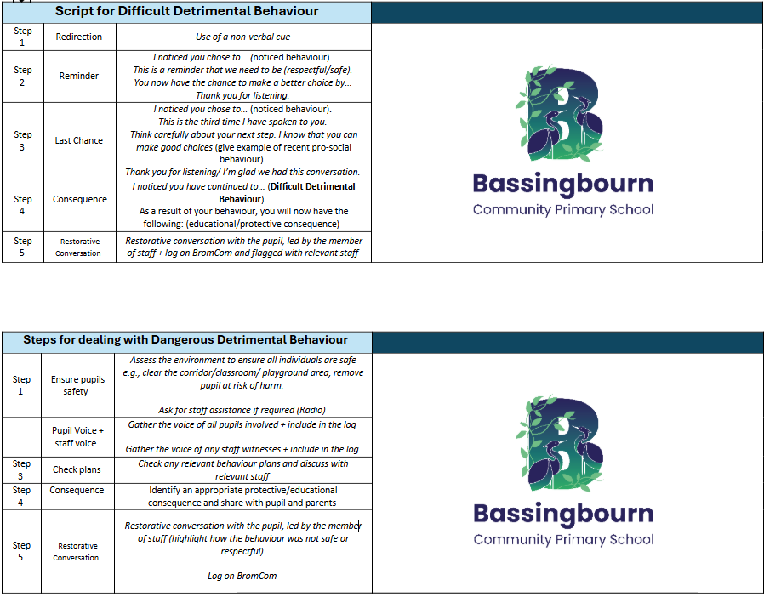

Appendix 2 – Early Prognosis document
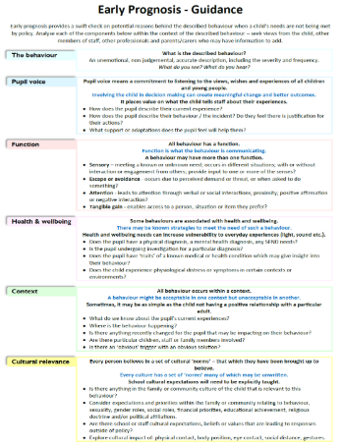

Appendix 3 – Early Prognosis document, assess, plan, do and review
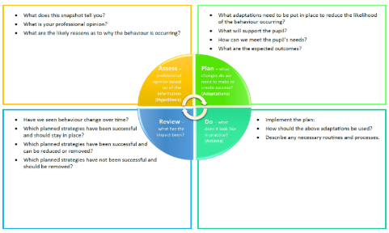
Appendix 4 – Risk calculator
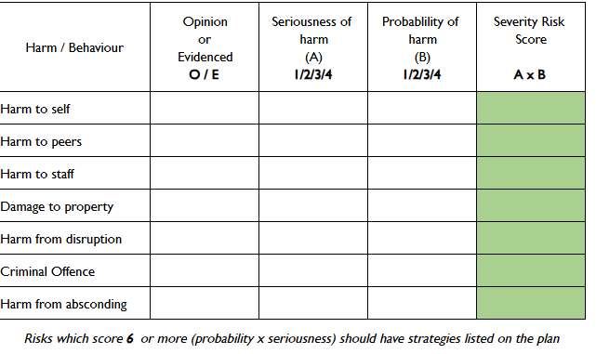

Appendix 5 - predict, prevent & progress plan
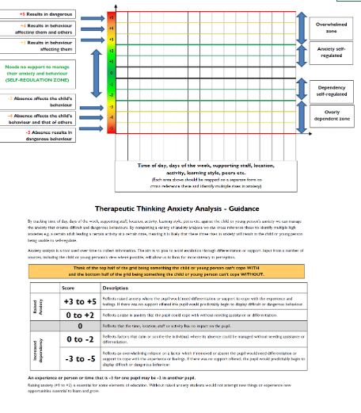

Appendix 6 - Therapeutic tree for the individual pupil
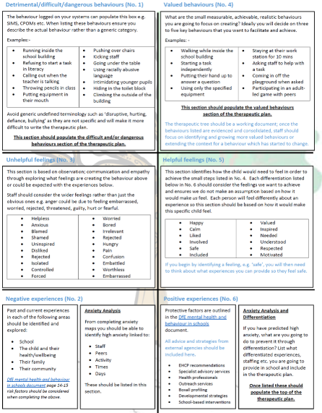

Appendix 7 - Therapeutic risk management plan
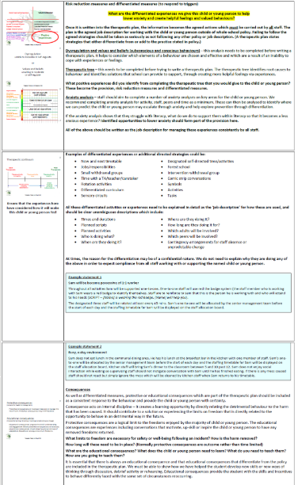

Appendix 8 – Behaviour report
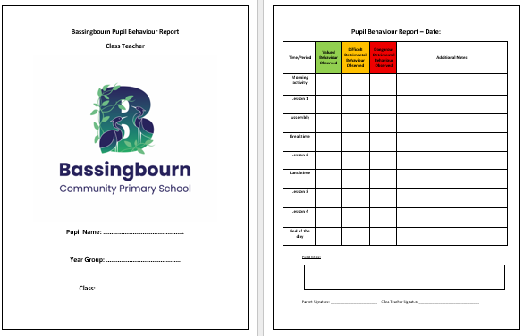

Appendix 9 - Therapeutic risk management plan
